2)what is mongoDB

Name comes from humongous, because you can store lots and lots of data and not just from data size perspective but also in sense of you can store lots of data and you can then work with it efficiently which of course is also super important.

So it’s a databse. But we already have databases(like mysql,postgre) how is it different?

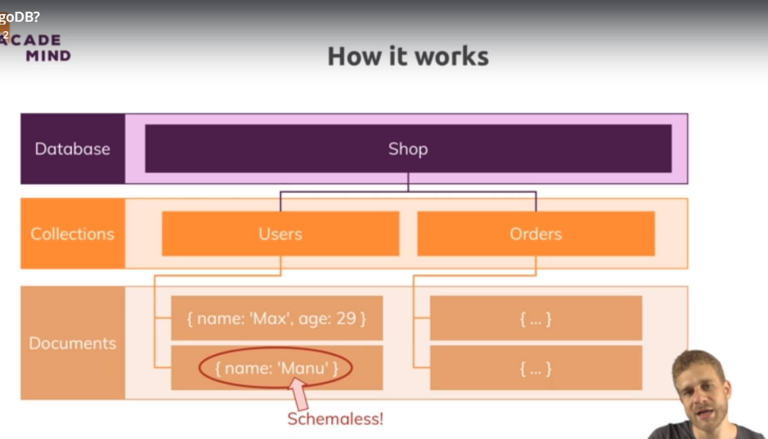

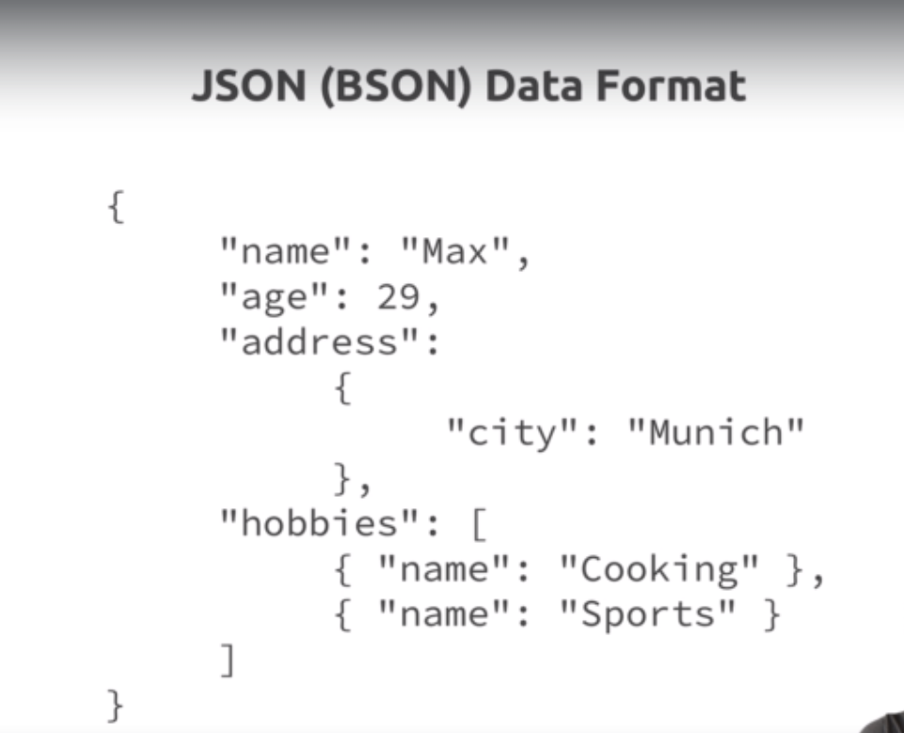

You can see address store a embedded document. This is another cool feature of mongo db. you can store nested data in there and why is that helpful? Well this allows you to create complex relations between data and store them in one and same document which makes working with it and fetching it super efficient. Where in sql you have to write complex joins to find data in table a and data in table ,here you can fetch it all in one document and you are good to go. So this is highly effiecient and allows you to store data in logical way.

In title it says bson instead of json, well behind the scenes on server , mongo converts your json data which is this format(you see here) into binary version of it which can basically be stored and can be queried more effieciently, you do need to worry about that, we work with this json thing, we work with this object thing throughout the course.

The whole theme of this video and mongo db is this flexibility and optimization for usability and that is what sets mongodb apart from other db solutions and which make it so awesome and so efficient from a performance prerspective too because you can query data in format you need it instead of running complex restructurings on server.

4)Understanding mongo DB Ecosystem

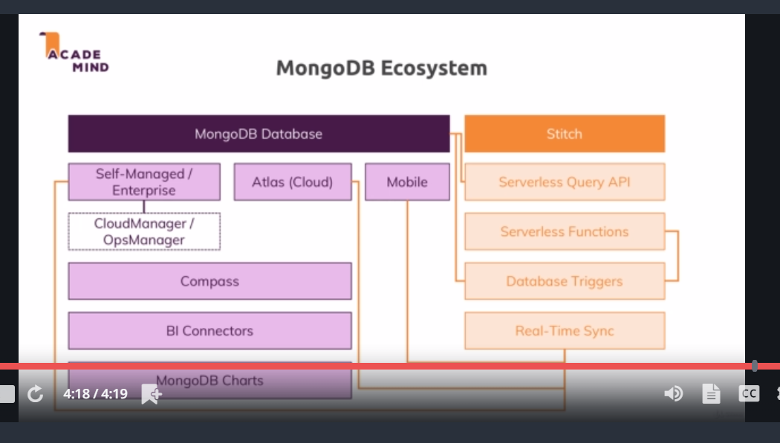

9)MongoDB + Clients: The Big Picture



